Item Discount Reason Code
User’s Guide



Table of Contents
1. Overview
2. Features
2.1 Login and Navigation
2.2 Item Discount Reason Code
2.3 Creating Reason Code
2.4 Reason Code Listing table
2.5 Actions – View, Edit and Activate/Deactivate
2.6 Blob generation and Device Sync
2.7 POS Validation
2.8 Post-Edit Validation
2.9 Logout

1. Overview
This document provides a step-by-step guide for creation, viewing, editing, activation, and deactivation of Item Discount Reason Codes in the XCO application, validating the blob generation, device sync, and checking the results on the POS.
2. Features
2.1 Login and Navigation
Login to the XCO application.
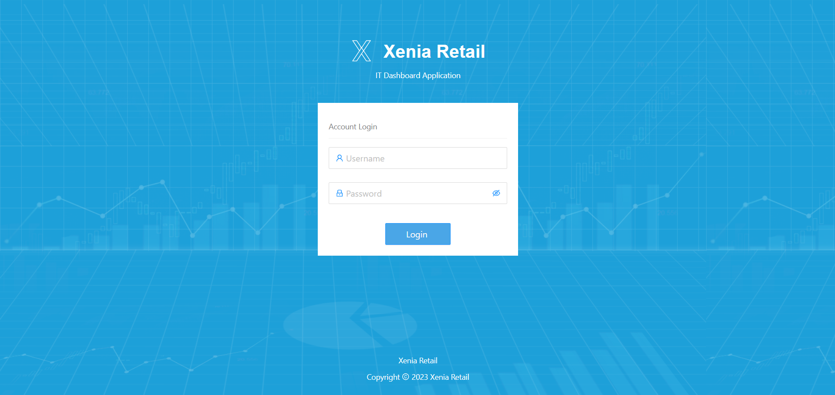
Navigate to the Reason Codes dropdown.
Select the Item Discount option.
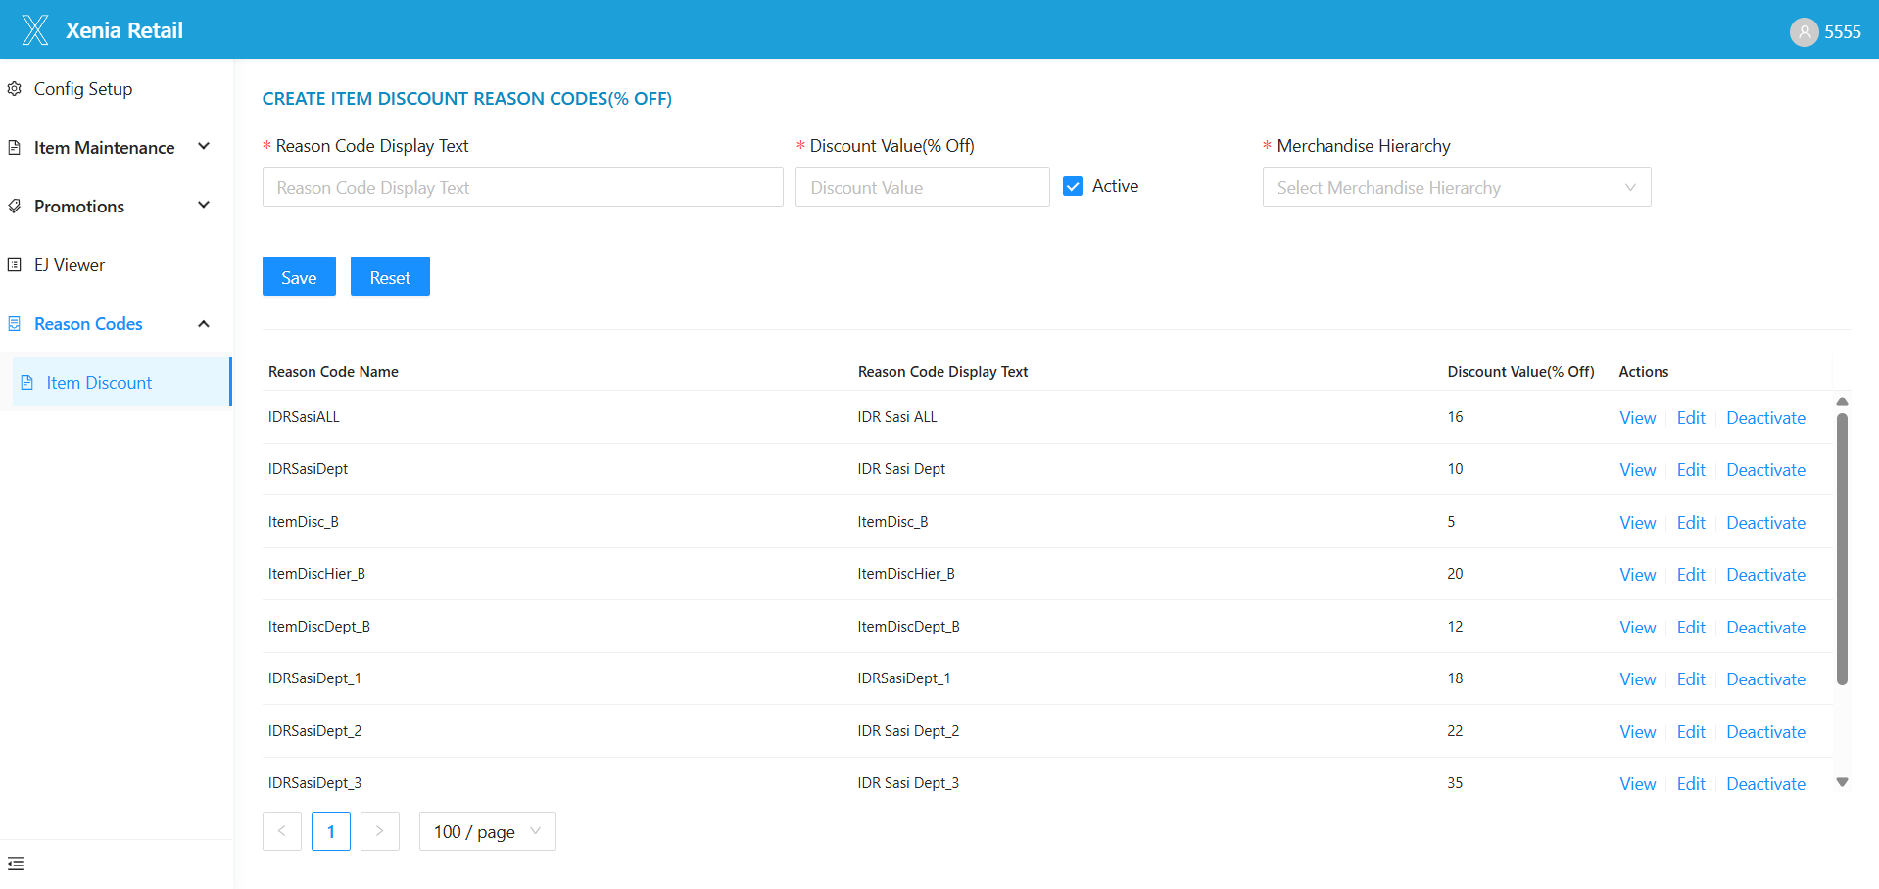
2.2 Item Discount Reason Code
On the Create Item Discount Reason Code (% Off) page, you will find the following fields:
- Reason Code Display Text – Enter the display name.
- Discount Value (% Off) – Enter the discount percentage (e.g., 5%, 10%).
- Active – Checkbox to make the reason code active or inactive.
- Merchandise Hierarchy – Dropdown options include:
  - All
  - Department
  - Line
  - Class
  - Subclass
- If All is selected: The discount will apply to all items.
- If Department, Line, Class, or Subclass is selected: A hierarchy list will appear, allowing you to select one or multiple options.
Buttons:
- Save – To save the reason code.
- Reset – To clear the entered fields.
2.3 Creating Reason Code
2.3.1 Selecting Merchandise Hierarchy as 'All'
Enter Reason Code Display Text, Discount Value (% Off), Check Active if you want it to be immediately usable, In the Merchandise Hierarchy dropdown, select All and Click Save.
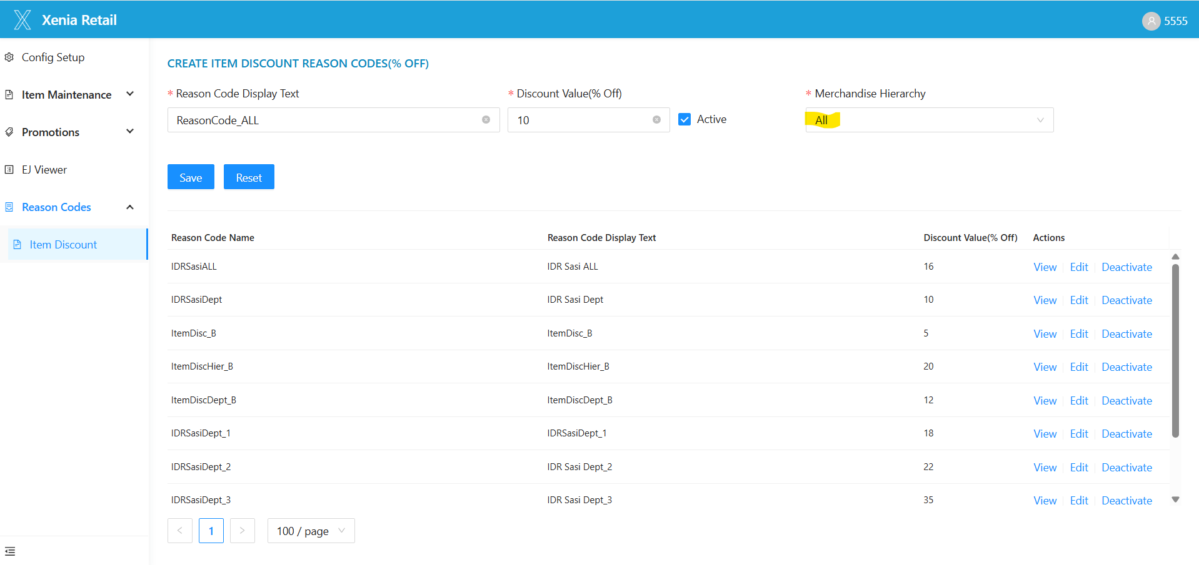
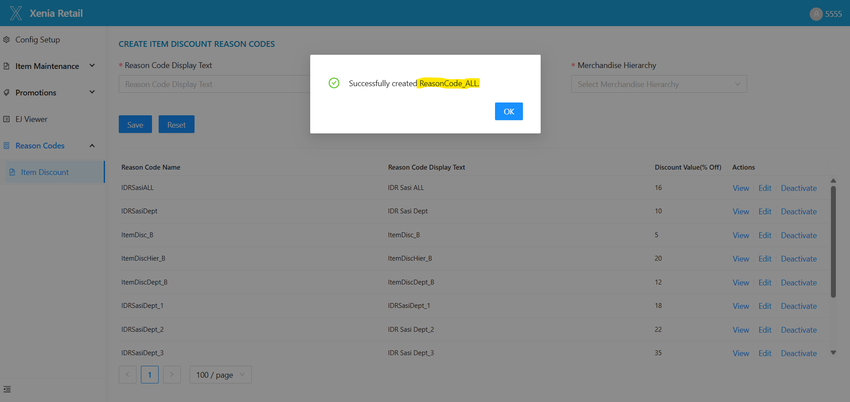
This reason code will apply to all items.
2.3.2 Selecting Specific Merchandise Hierarchy (Department, Line, Class, Subclass)
Enter Reason Code Display Text, Discount Value (% Off), Check Active if required, In the Merchandise Hierarchy dropdown, select any of:
  - Department
  - Line
  - Class
  - Subclass
A Hierarchy List dropdown will appear; select one or multiple options and Click Save.
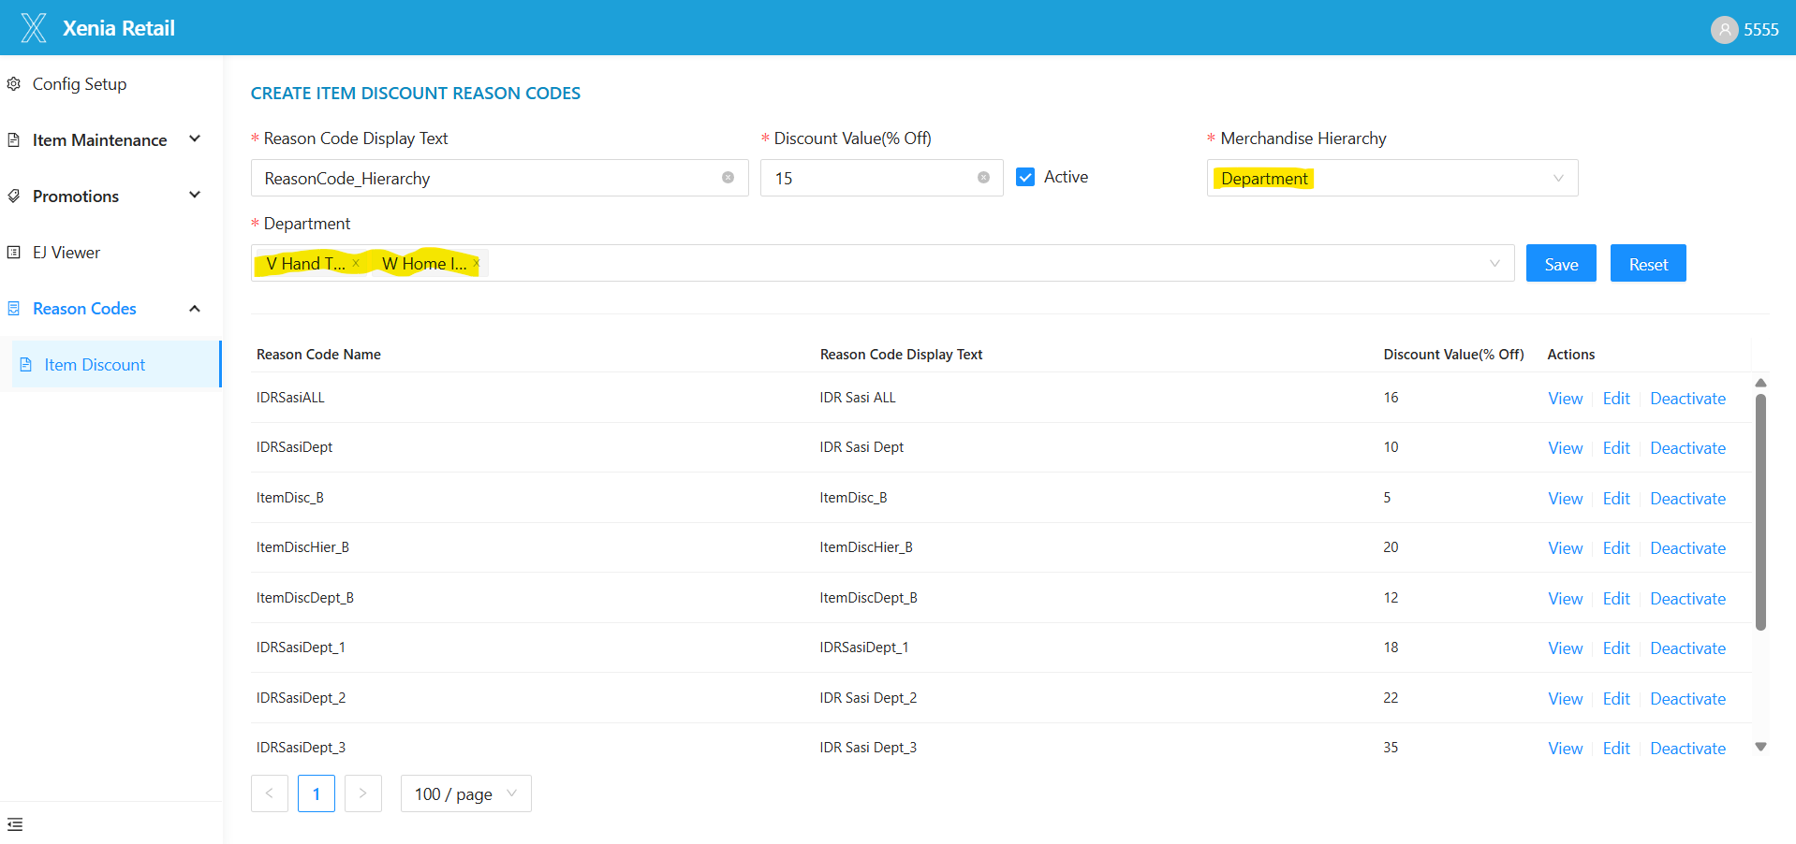
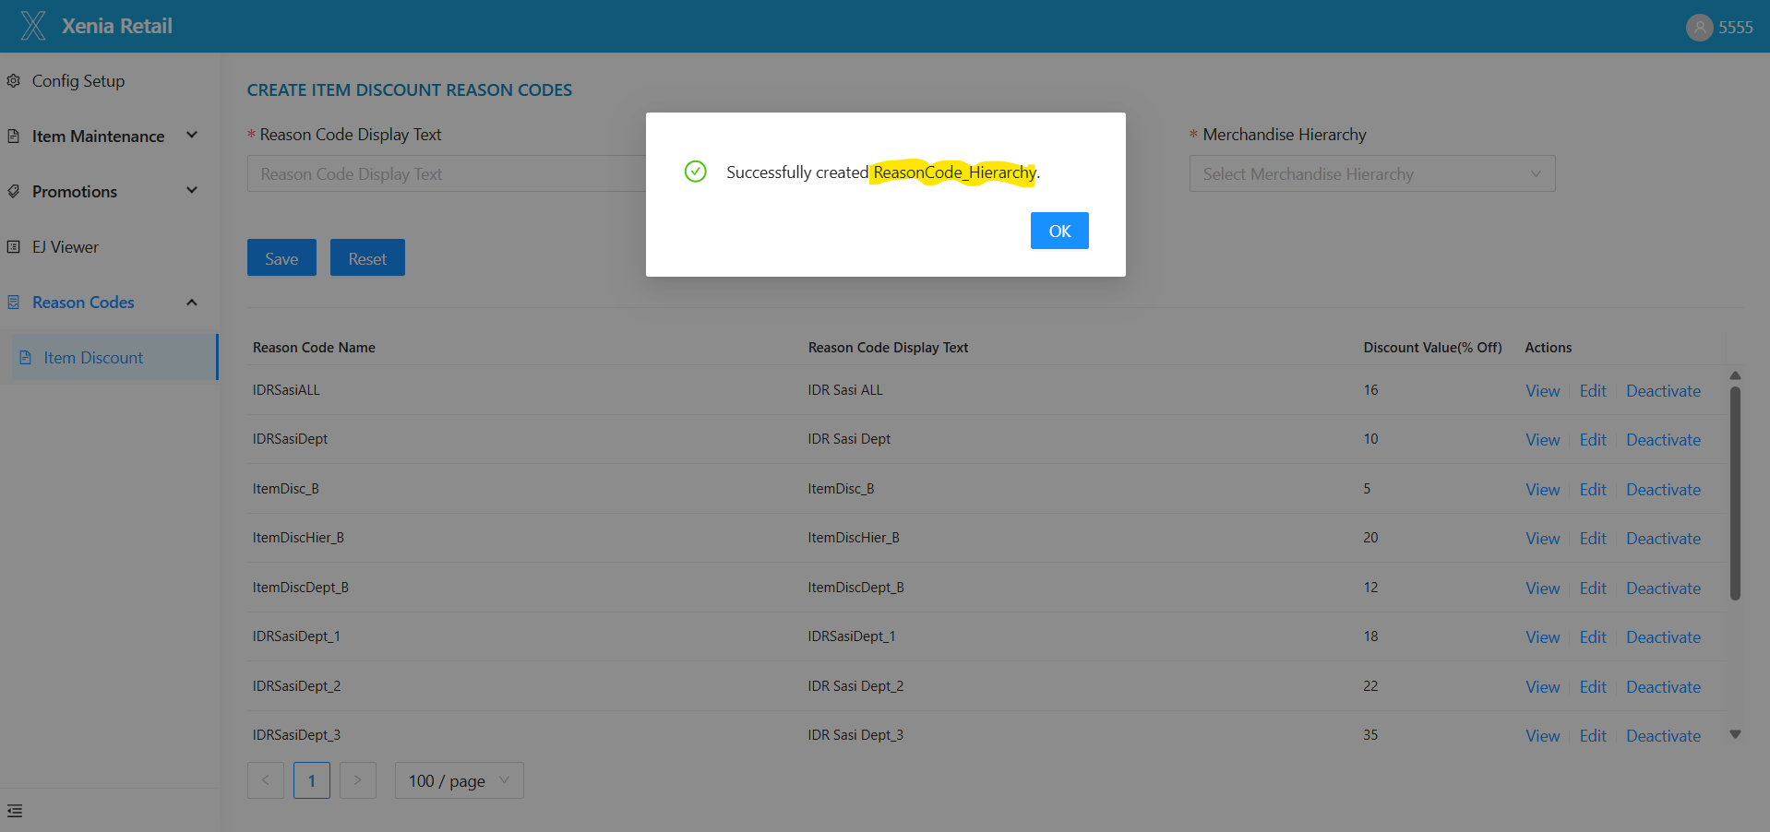
This reason code will apply only to selected items under the chosen hierarchy.
2.4 Reason Code Listing Table
After creation, the reason code appears in a table with the following columns:
- Reason Code Name
- Reason Code Display Text
- Discount Value (% Off)
- Actions: View, Edit, Activate/Deactivate
You can control pagination using:
- 10/Page, 20/Page, 50/Page, 100/Page
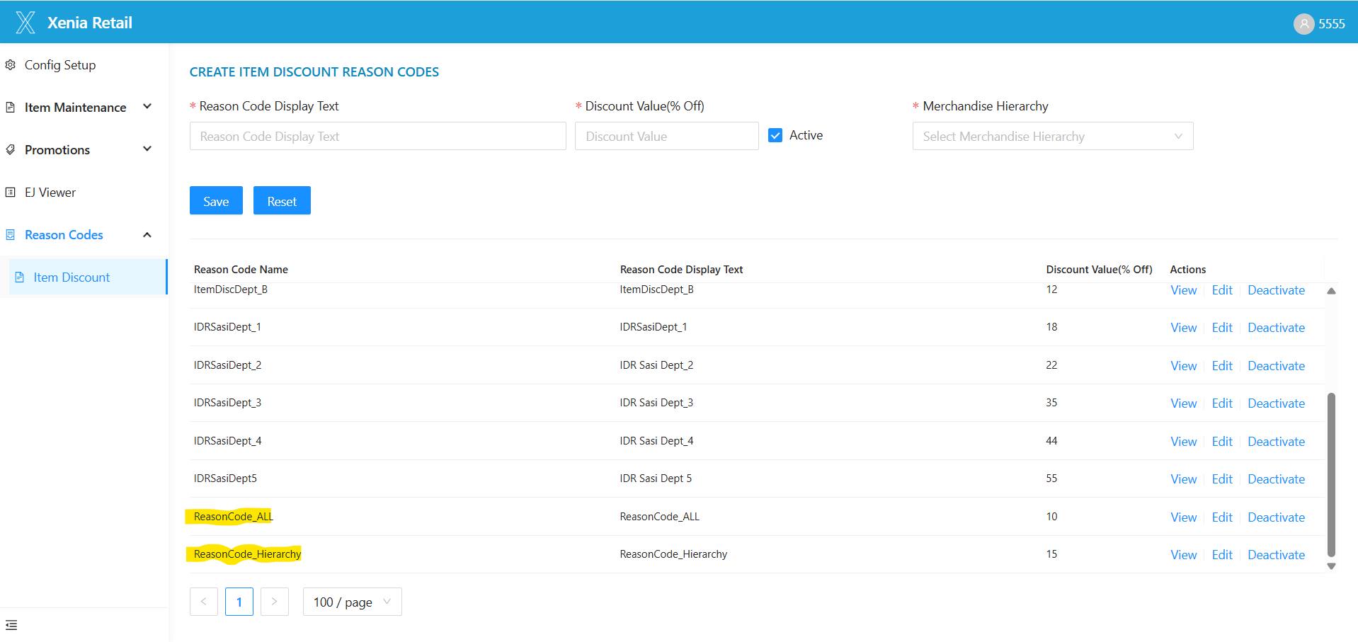
2.5 Actions – View, Edit and Activate/Deactivate Reason Codes
View Reason Code
Click the View button under the Actions column.
The Item Discount Reason Code Details popup will display:
- Reason Code Display Text
- Discount Value
- Status (Active/Inactive)
- Merchandise Hierarchy Level
- Hierarchy List values
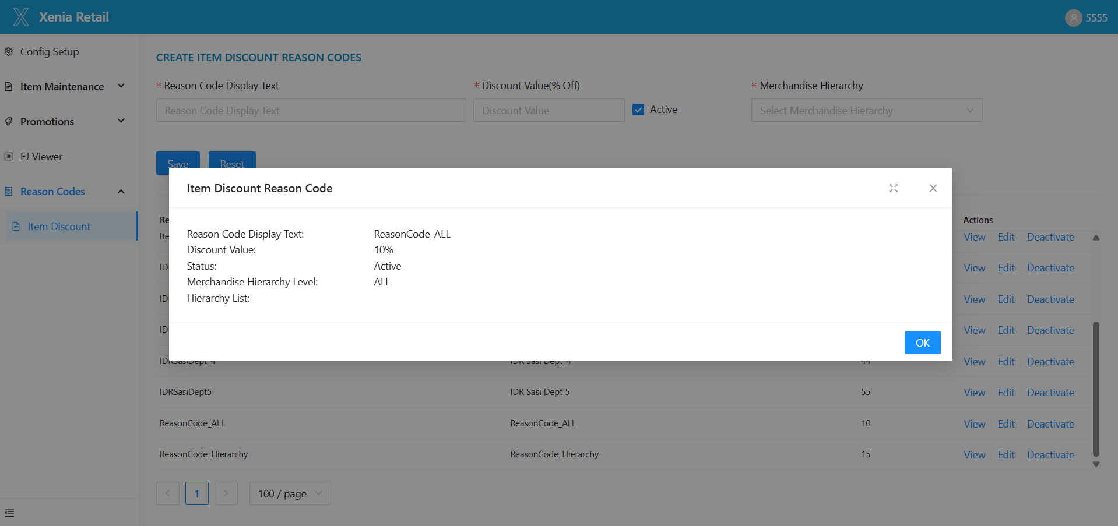
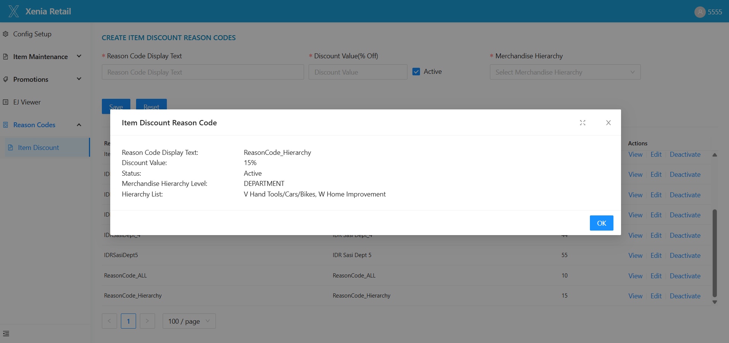
Popup Controls:
- Full-screen icon
- OK
- Close

Edit Reason Code
Click the Edit button under the Actions column.
On the edit page:
- Reason Code Display Text is disabled.
You can update:
- Discount Value (% Off)
- Active status
- Merchandise Hierarchy Level
- Hierarchy List values
Click Save to update the reason code.
The changes will reflect in the table and will be pushed to devices.
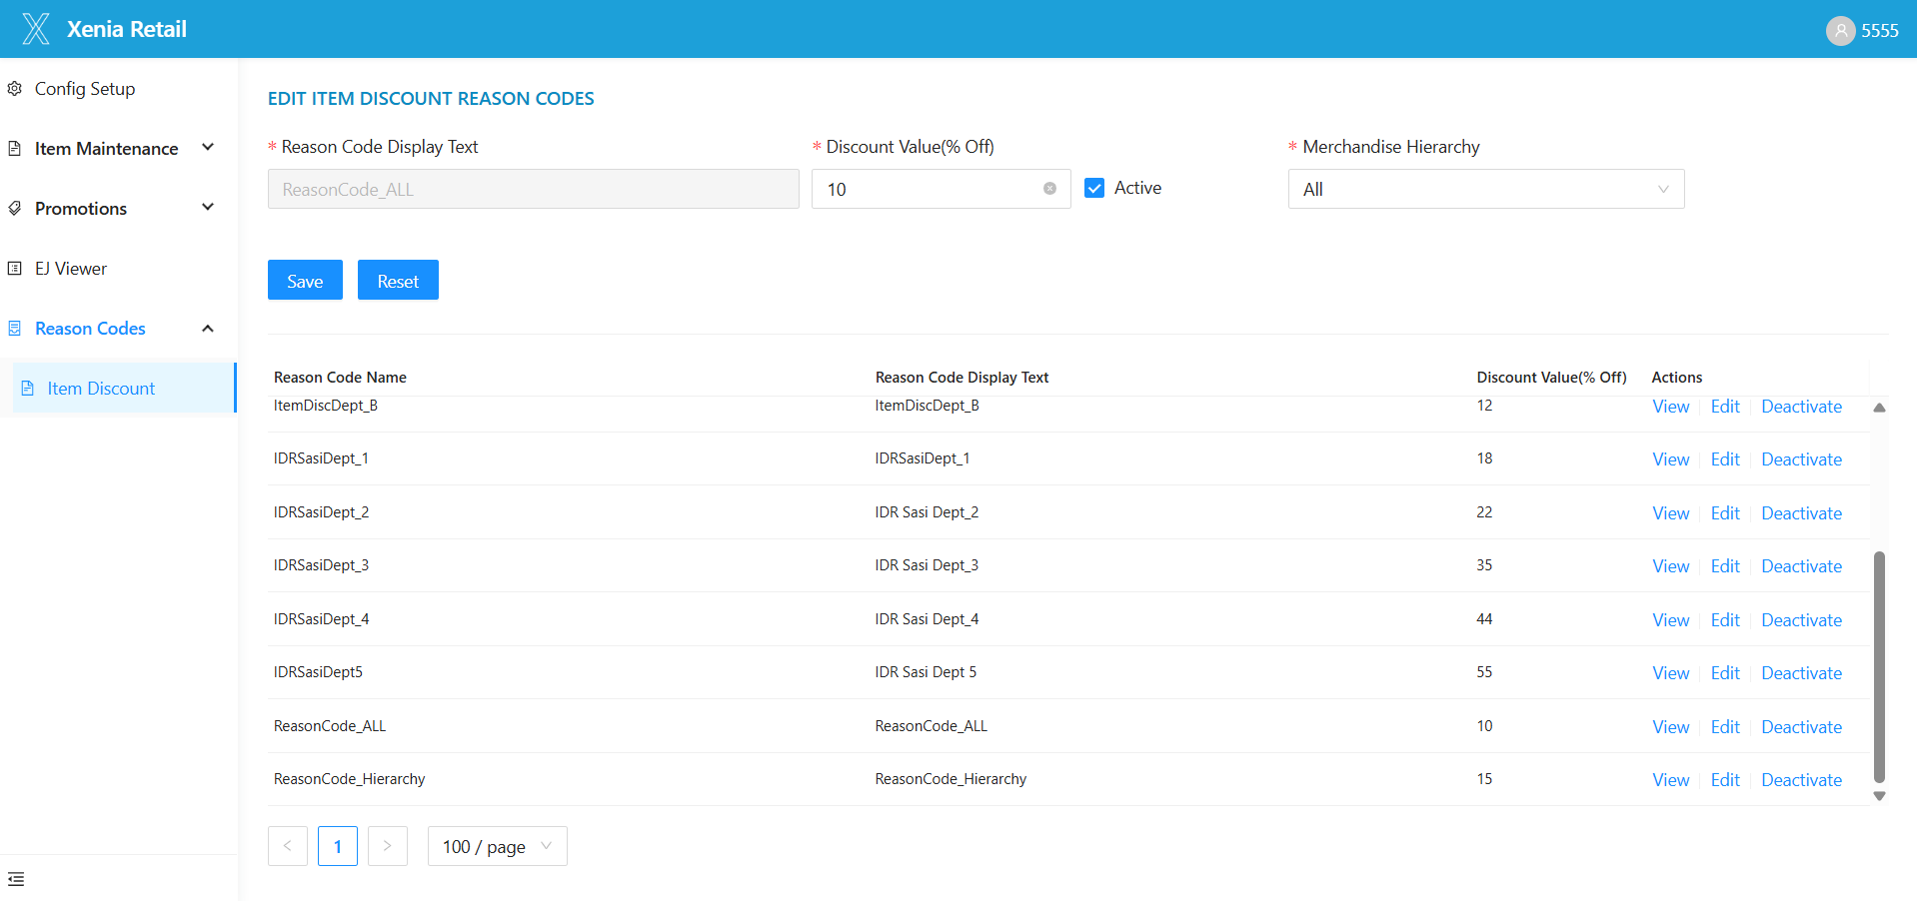

Activate / Deactivate Reason Code
Each reason code will display either an Activate or Deactivate button in the Actions column, depending on its status.
Deactivate
- If a reason code is Active, clicking Deactivate will:
  - Set the status to Deactivate.
  - The reason code will not appear in the POS application.
Activate
- If a reason code is Deactivate, clicking Activate will:
  - Set the status to Active.
  - The reason code will appear in the POS application.
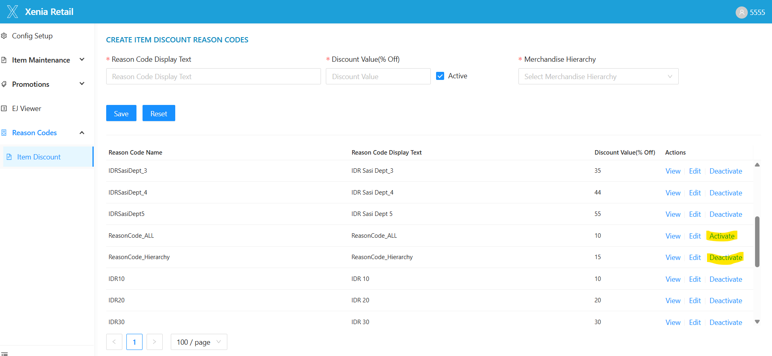

2.6 Blob Generation and Device Sync
After creating or editing a reason code:
A DiscountReasonCodes blob is generated.
It is uploaded to the cstodevicessync blob container.
The DiscountReasonCodes blob is updated every 5 minutes.
On the device:
- Verify the datasync logs to check if the blob has been processed.
- Check the reference tables in Database to ensure reason code data is updated.
- Restart the MRF services on devices.
- Relaunch the POS application to reflect updated reason codes.

2.7 POS App Validation
Launch the POS application.
Add an item to the POS
Confirm the Item Discount option is available.
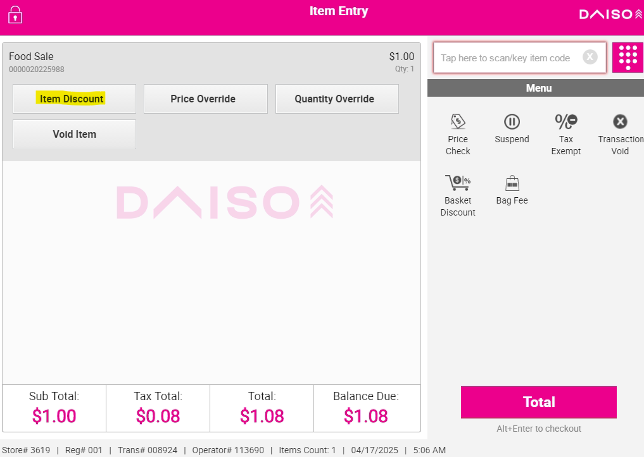
Click on Item Discount, Reason codes options will be displayed.
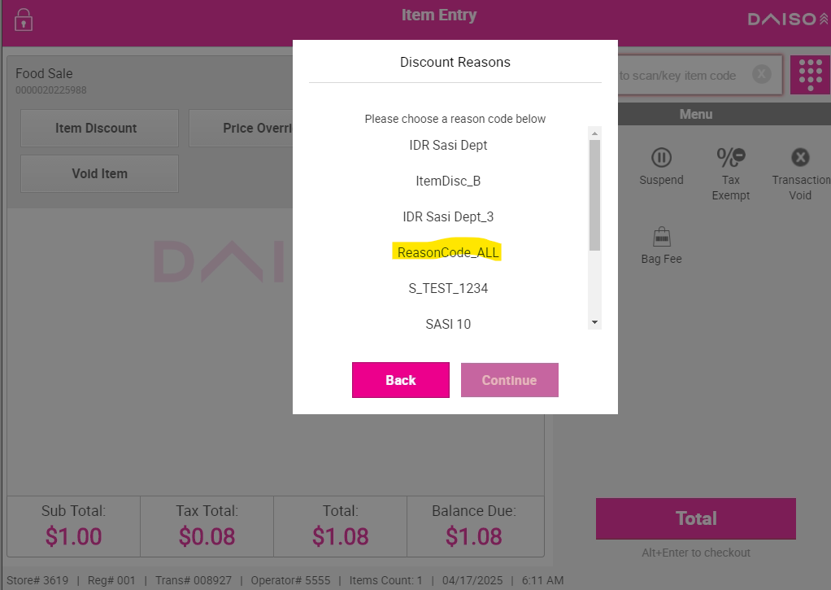
Apply the reason code created in XCO.
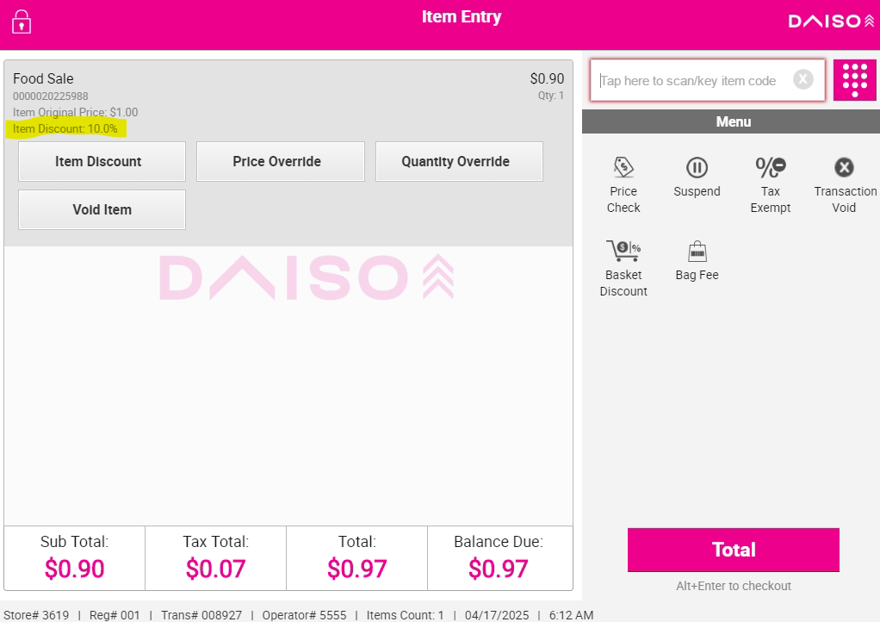

Complete the transaction.
Verify:
- The discount is applied and displayed correctly on POS.
- The receipt reflects the correct discount.

2.8 Post-Edit Validation
After editing a reason code:
Wait for the updated DiscountReasonCodes blob to be generated and synced (within 5 minutes).
Restart MRF services on the device.
Reopen the POS app.
Test the changes:
- Confirm updated discount value.
- Confirm updated applicability (All, Dept, Line, Class, Subclass).
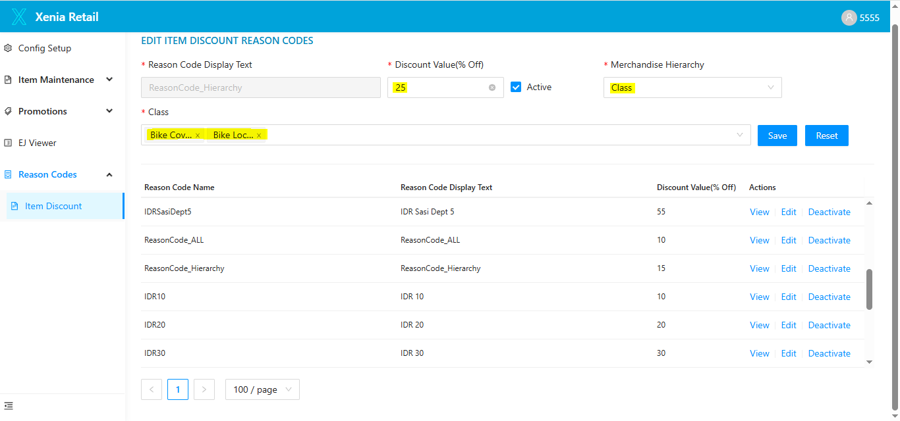

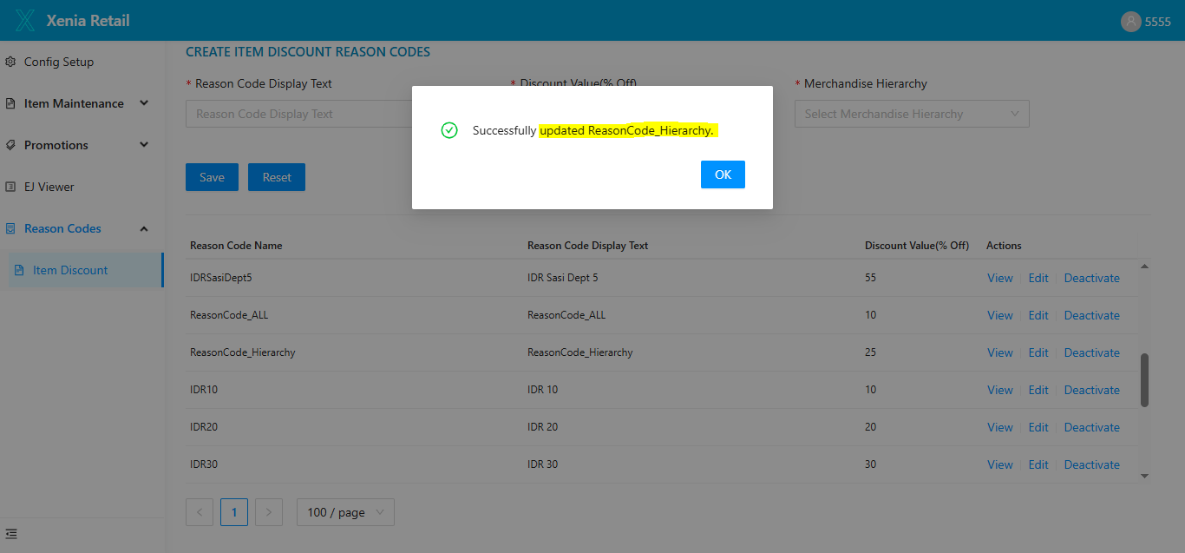

Complete a new transaction and verify:
- Discount applied and displayed correctly on POS.
- Receipt reflects the updated discount.
2.9 Logout
1. To log out, click the Log Out icon at the top right of the screen.
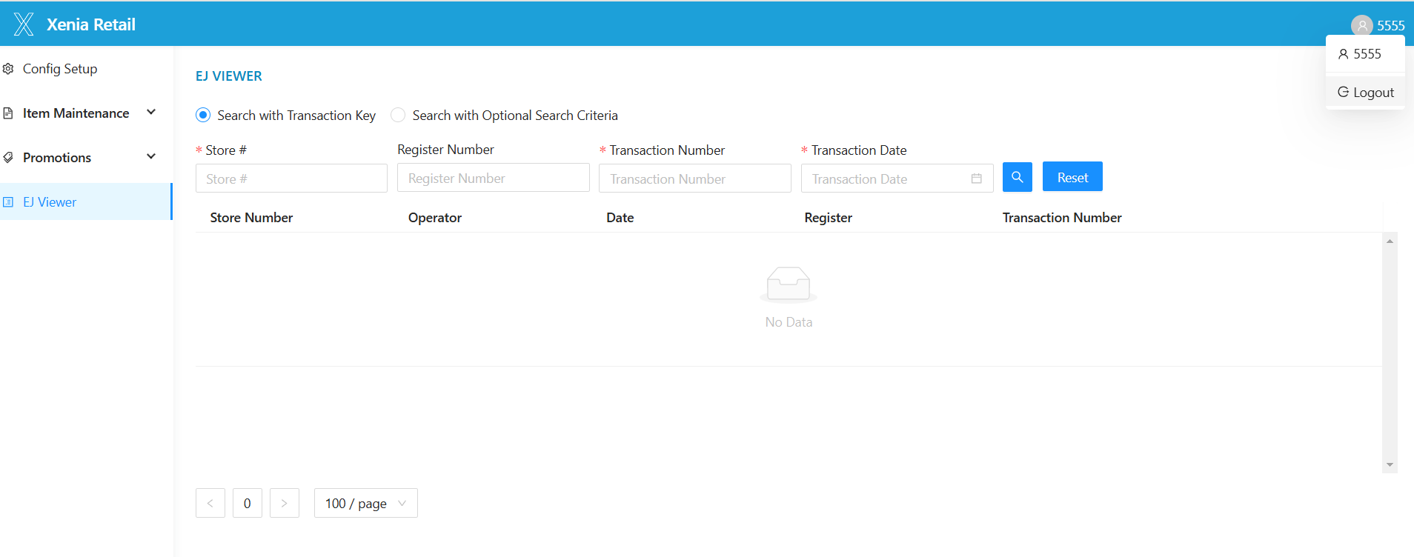

2. The system will log you out and return you to the pricing UI sign-in screen.
NOTE: If you create a new item discount reason code it will be downloaded to stores in ~2 hours. Say, you create a reason code between 8:00 AM and 8:55 AM PST, the blob will be generated at 9:00 AM and synced to devices at 10:00 AM. After 10:00 AM, you need to restart the MRF services and relaunch the POS to test the item discount reason code you created. Please note that if you create a reason code overnight(~10pm) then it will process to stores after nightly reboot at 2AM.

